# Laboratory 4

Title of the Laboratory Exercise: Controlling execution flow using conditional instructions

1. Introduction and Purpose of Experiment

Students will be able to perform control flow operations using conditional instructions

1. Aim and Objectives

Aim

To develop assembly language program to perform control flow operations using conditional instructions.

Objectives

At the end of this lab, the student will be able to

* + Identify the appropriate assembly language instruction for the given conditional operations
  + Perform all conditional operations using assembly language instructions
  + Get familiar with assembly language program by developing simple programs

1. Experimental Procedure

1. Write algorithm to solve the given problem

2. Translate the algorithm to assembly language code

3. Run the assembly code in GNU assembler

4. Create a laboratory report documenting the work

1. Questions

Develop an assembly language program to perform the following

1. Print all even numbers in ‘n’ natural numbers
2. Print all odd numbers in ‘n’ natural numbers
3. Compute GCD for the given two natural numbers
4. Compute LCM for the given two natural numbers
5. Develop an assembly language program to generate the first n numbers in Fibonacci series.
6. Calculations/Computations/Algorithms

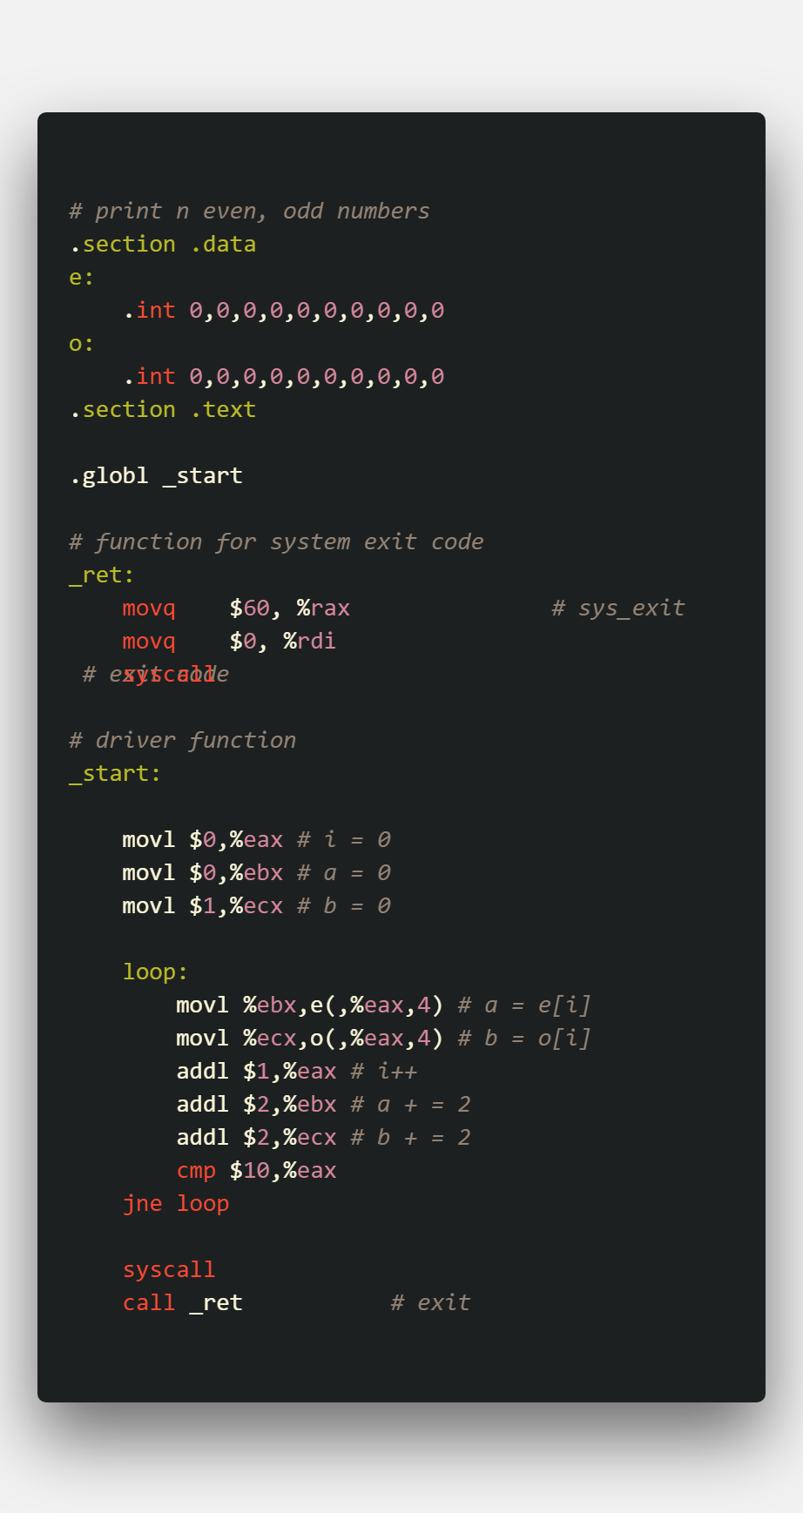

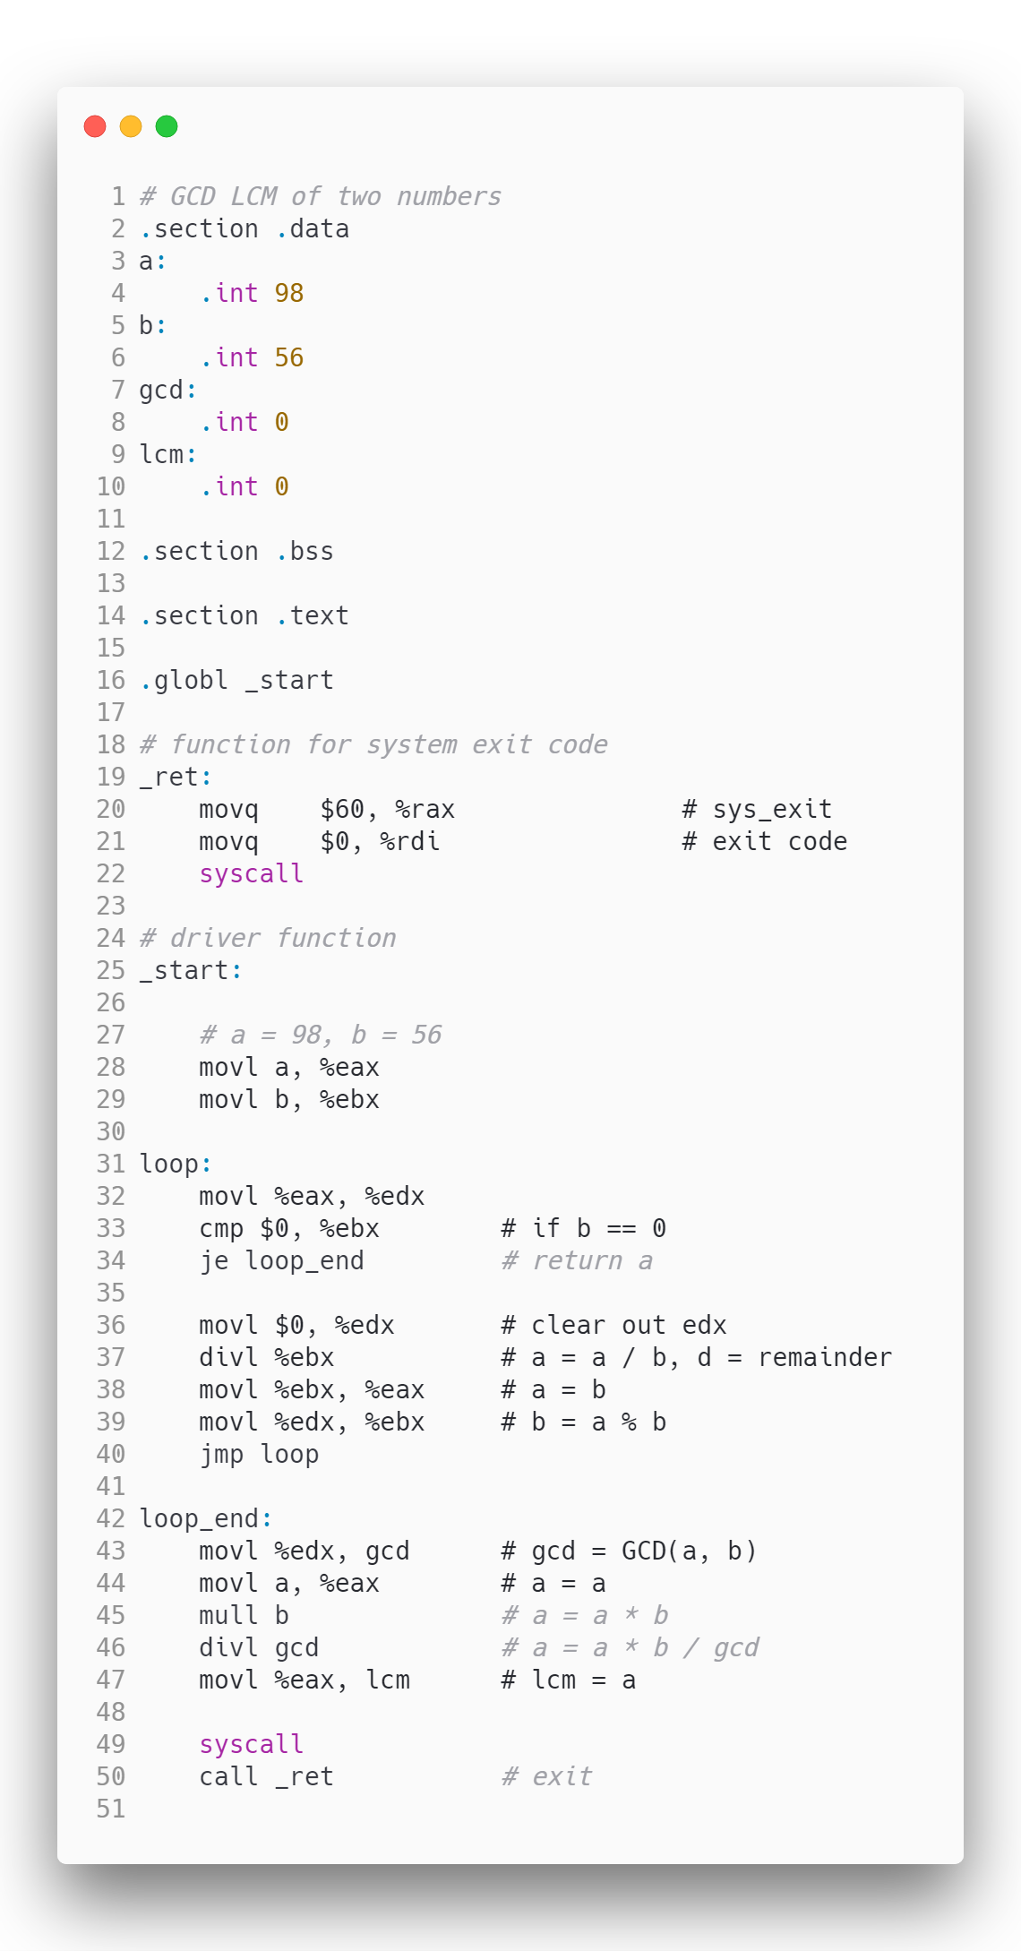

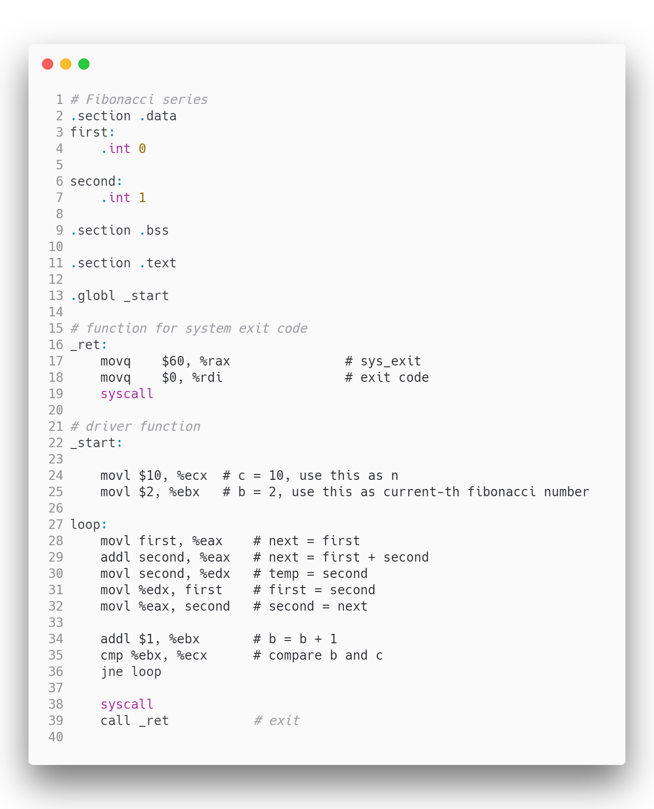

1. Presentation of Results

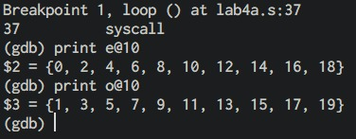

Figure 1 odd and even numbers

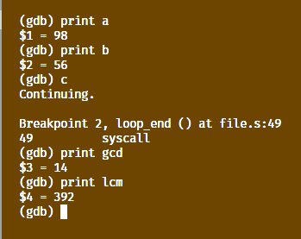

*Figure 2 LCM and GCD of two numbers*

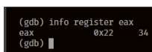

Figure 3 fibonacci series

1. Analysis and Discussions

|  |  |
| --- | --- |
| Code | jmp address |
| Example | jmp loop |
| Explanation | Performs:  Jumps to the address location  Description:  Transfers program control to a different point in the instruction stream without recording return information. The destination (target) operand specifies the address of the instruction being jumped to. This operand can be an immediate value, a general-purpose register, or a memory location.  This instruction can be used to execute four different types of jumps: - Near jump-A jump to an instruction within the current code segment (the segment currently pointed to by the CS register), sometimes referred to as an intrasegment jump. |

|  |  |
| --- | --- |
| Code | jcc address |
| Example | jne loop |
| Explanation | Performs:  Jumps to the address location if the condition is met  Here cc = ne, e, ge, g, etc.  Description:  Checks the state of one or more of the status flags in the EFLAGS register (CF, OF, PF, SF, and ZF) and, if the flags are in the specified state (condition), performs a jump to the target instruction specified by the destination operand. A condition code (cc) is associated with each instruction to indicate the condition being tested for. If the condition is not satisfied, the jump is not performed and execution continues with the instruction following the Jcc instruction. |

|  |  |
| --- | --- |
| Code | cmp op1 op2 |
| Example | cmp $0, %eax |
| Explanation | Performs:  Compares the two operands  Description:  Compares the first source operand with the second source operand and sets the status flags in the EFLAGS register according to the results. The comparison is performed by subtracting the second operand from the first operand and then setting the status flags in the same manner as the SUB instruction. When an immediate value is used as an operand, |

1. Conclusions

Execution Flow can be controlled by using conditional instructions, which includes a cmp instruction followed by a jump instruction, a cmp instruction compares the two operands and updates the flag register, this is then used with jump instruction to go to some other part of the program, using this we can form looping structures to do stuff like print n natural numbers, sum of them and some basic programs like LCM and GCD of two numbers, even functions can be emulated in assembly by using such structures.

1. Comments

1. Limitations of Experiments

Although looping structures can be formed using the cmp, jcc instructions but recursive structures are complex to form using just these instructions.

2. Limitations of Results

None.

3. Learning happened

We learnt the use of compare, unconditional jump and conditional jump instructions to form looping structures and conditional statements.

4. Recommendations

Since a program can contain numerous loop labels, each label should be carefully names, and the programmer must keep track of which parts of the program jump to where, else there might be chances of forming infinite loops.

Signature and date Marks